**What are the best practices for designing high-availability systems?**

* High-availability systems are designed to minimize downtime and maximize performance, reliability, and user satisfaction. They are essential for critical applications and services that cannot afford to fail or slow down.
* The percentage of time the system is **up** and **performing** its intended function
* The availability is important for a system, any minute a system down can cause huge revenue loss.
* A air traffic system will always require high level of availability than a restaurant reservation system.
* If the system is 90% available the then it will be 36.5 day will be down a year(huge loss).

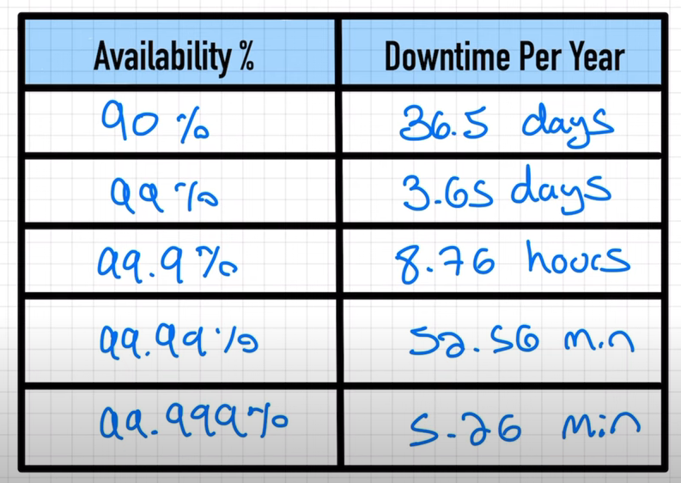

* **Reasons why service would fail for high availability.**
* Hardware failure
* Servers crash
* Power outages
* Natural disasters
* Resources run out (over usage/overloaded and not accept new request)
* Software bugs/defects can cause various ways(memory leaks/ software developer are not good)
* **How can we eliminate high availability failure**
* We can achieve it by eliminating single point of failure.

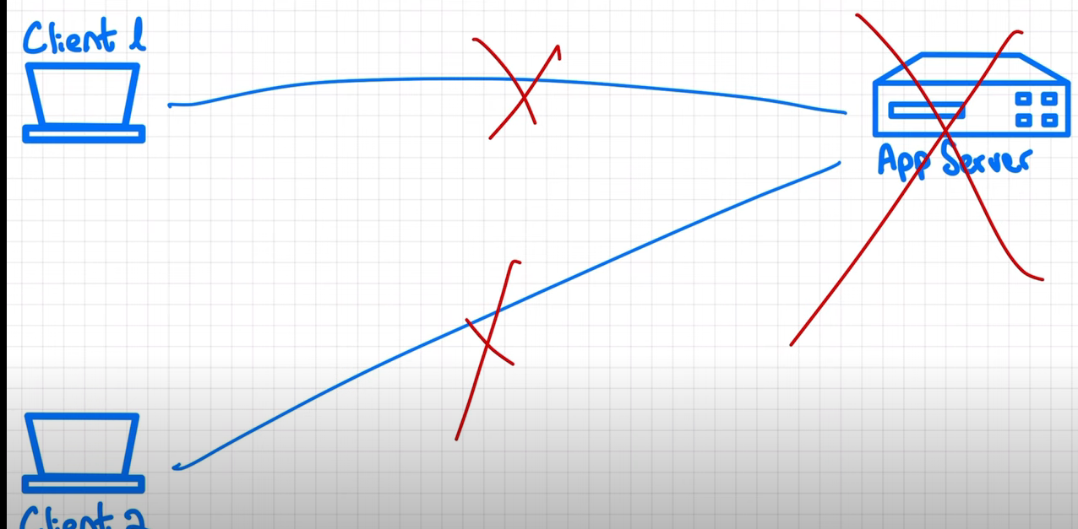

* If the app server goes down then all the clint will start failing there will be no alternat server to reroute the requests which is the **single point failure**.
* Also as the client increase the app server will become boatel neck and we will need to have power full machine to server more requests per seconds.
* To eliminate the single point of failure we can multiple app servers(not instances) in order to serve more request.

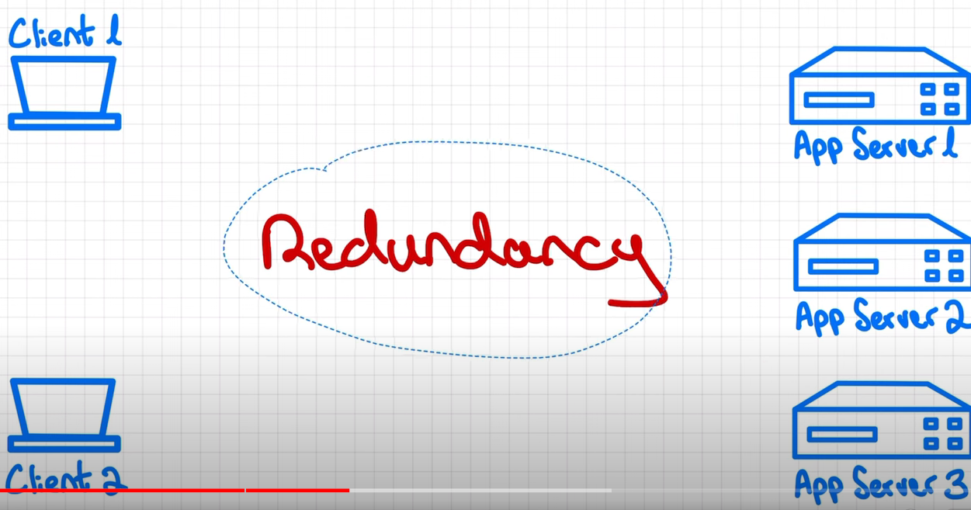

* Redundancy meanc duplicating part of the system if one goes down the other one will pick up the request and system will stay available.

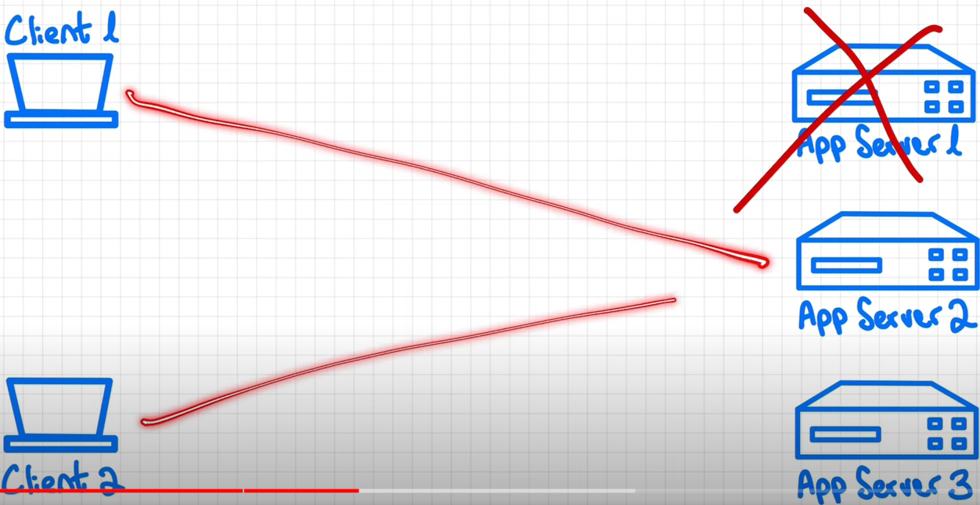

* Also having multiple servers running parallel request also can be survived parallel.

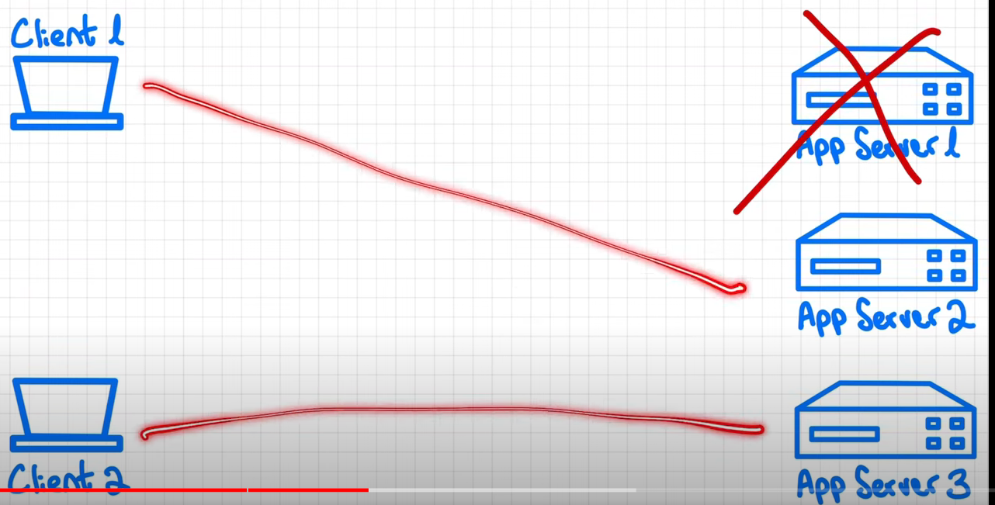

* **But having multiple servers running how do the client knows which server needs to be connected and not to connect to the dead server.**

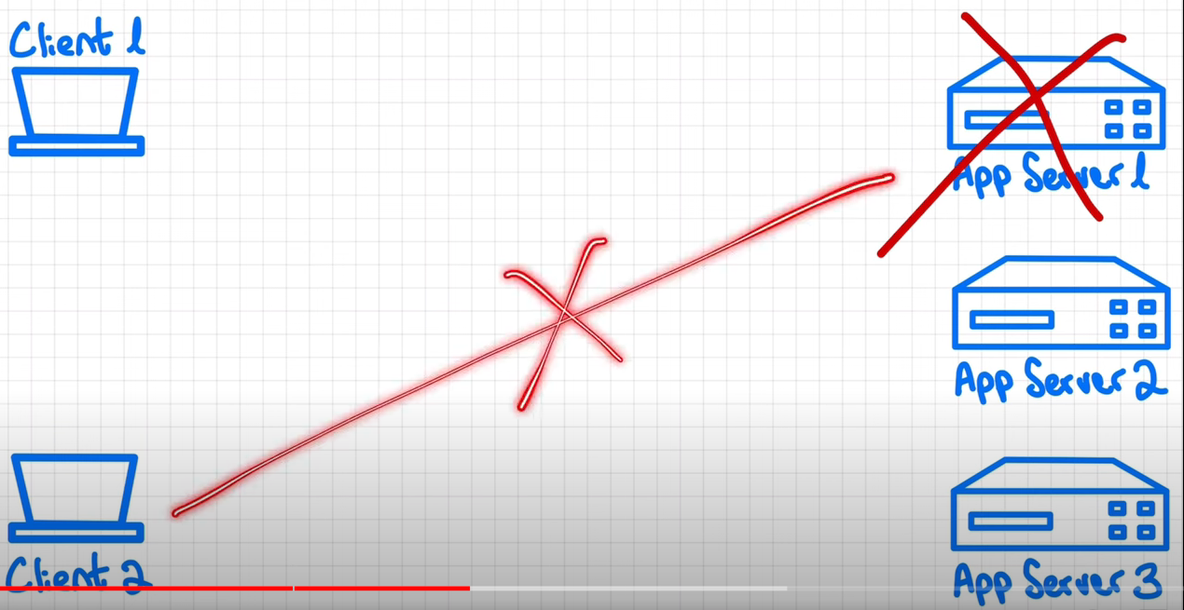

* This can be dene by using the **load balance between app** servers and clients

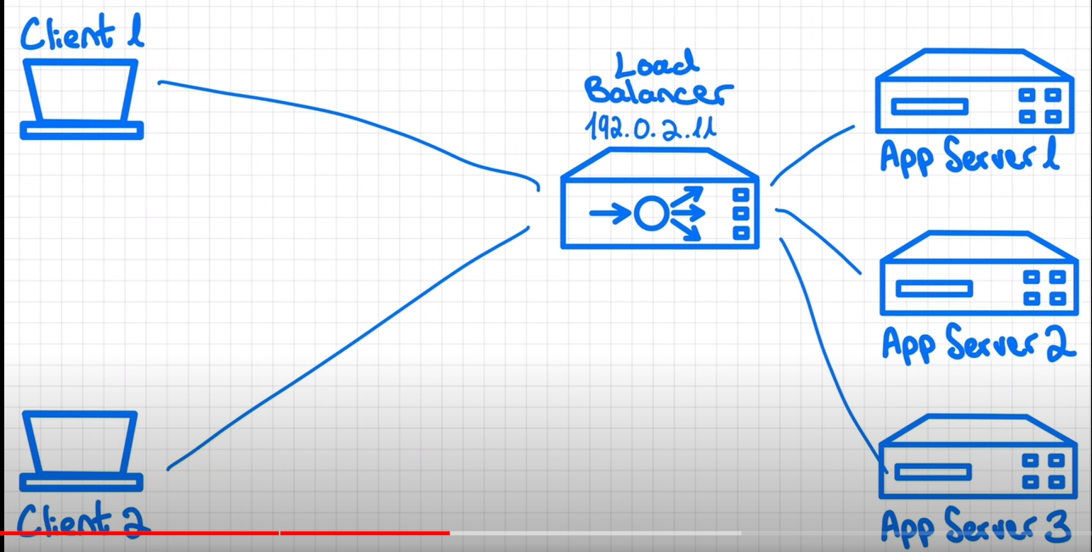

* Client request will first reach to load balance and then load balancer will decide which server should send the request.
* Load blancher is also aware of the state of the each server(liveliness and readiness).
* Meaning if any of the server dies the load blancer will become aware of that and will reroute the new request to other alive server until the dead server recovers.
* Load balancer will do that based on some distribution strategy (round robin or hashing technic).
* But in this case a **load balancer will be a single point of failure.**
* **What if our load balancer itself fails (single point of failure).**
* In this case the client request will go nowhere and app server will become unreachable.

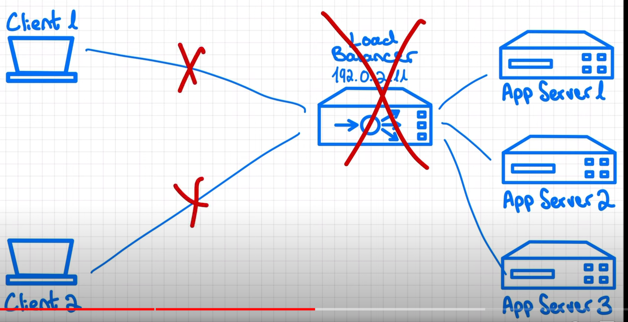

* Solution for that is the redundancy of load balancer.

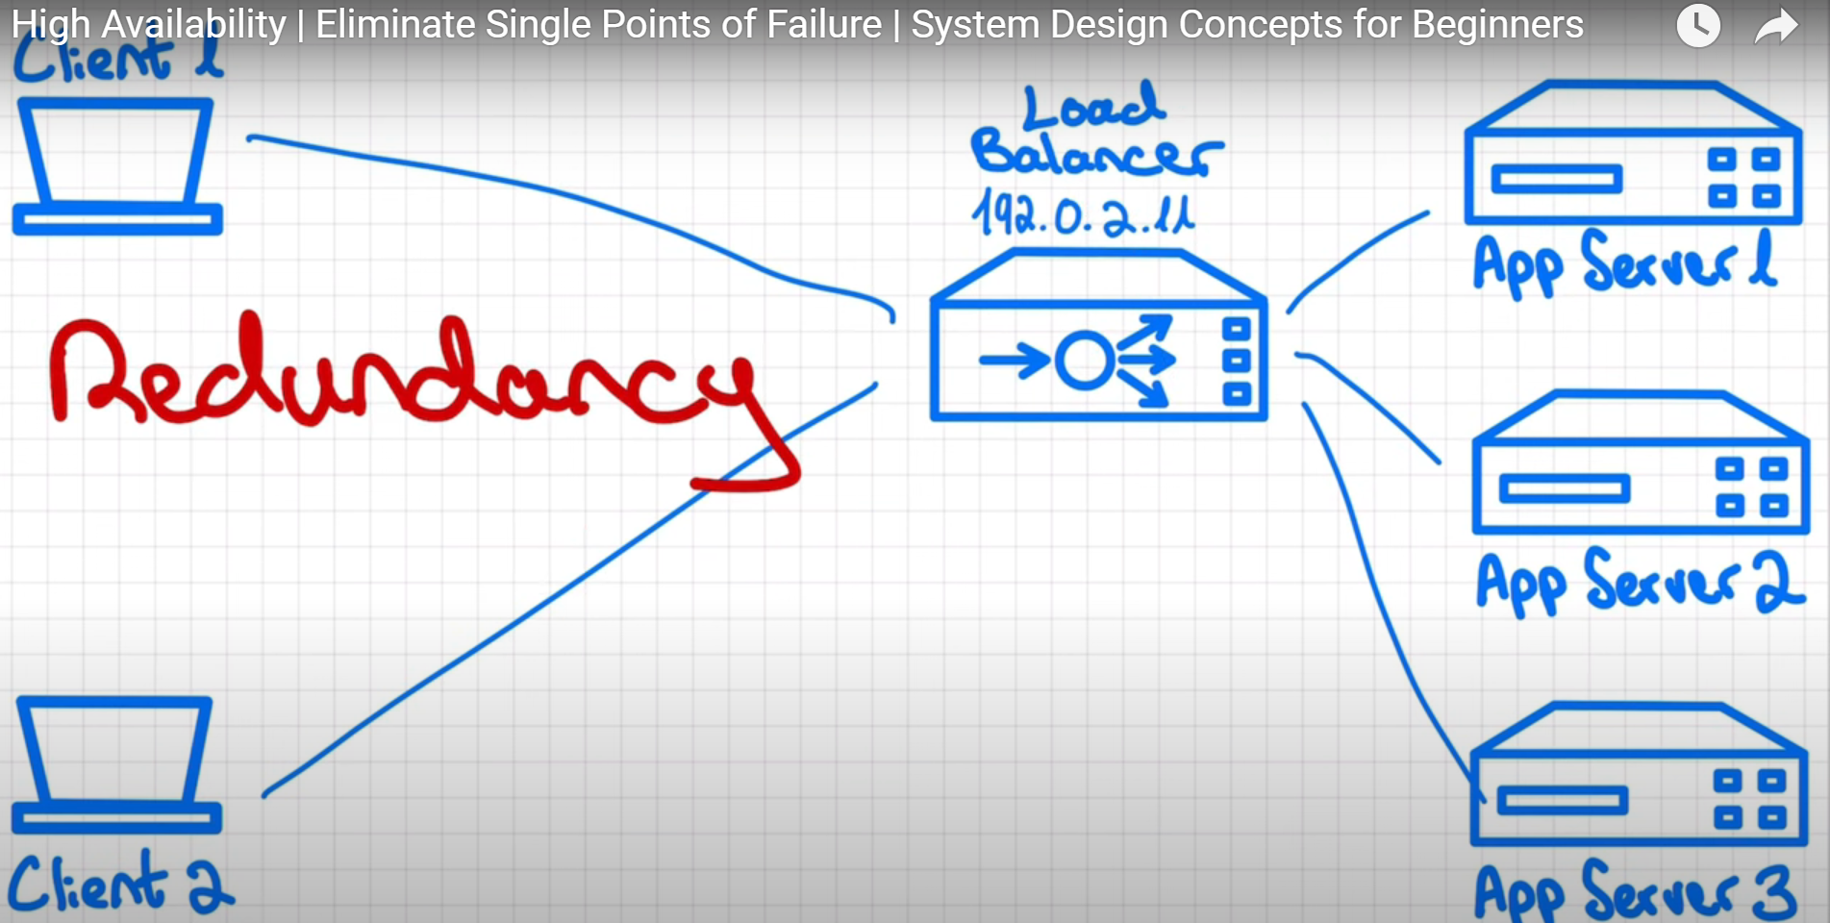

* There are generally 2 ways to it solution.
* If the load balancer (primary) is not bottleneck itself then we can create a backup of load balancer just for the recovery purpose.
* We can add 2nd load balancer (secondary) which will remain passive but will not accept any of client request. Only in case of failure, it will come in action and will take over (start accepting requests).
* This failover functionality from primary to secondary can be implemented using floating IP and healthcheck service between both primary and secondary load balancers.
* Floating IP is type of virtual IP that is mapped to one of the load balancer (primary or secondary) and acts as gateway to the client request.
* In healthy state, floating IP will send request to primary load balancer.
* Two load balancers will check each other’s health by sending heartbeat messages back and forth.
* If primary load balancer dies, health check will fail and then secondary will know it needs to take over.
* Secondary load balancer will do something like running the script to reassign the floating IP to its own. It will start accepting all subsequent requests.
* When primary load balancer becomes alive, it will reassign floating IP to itself and secondary will go back to being passive.

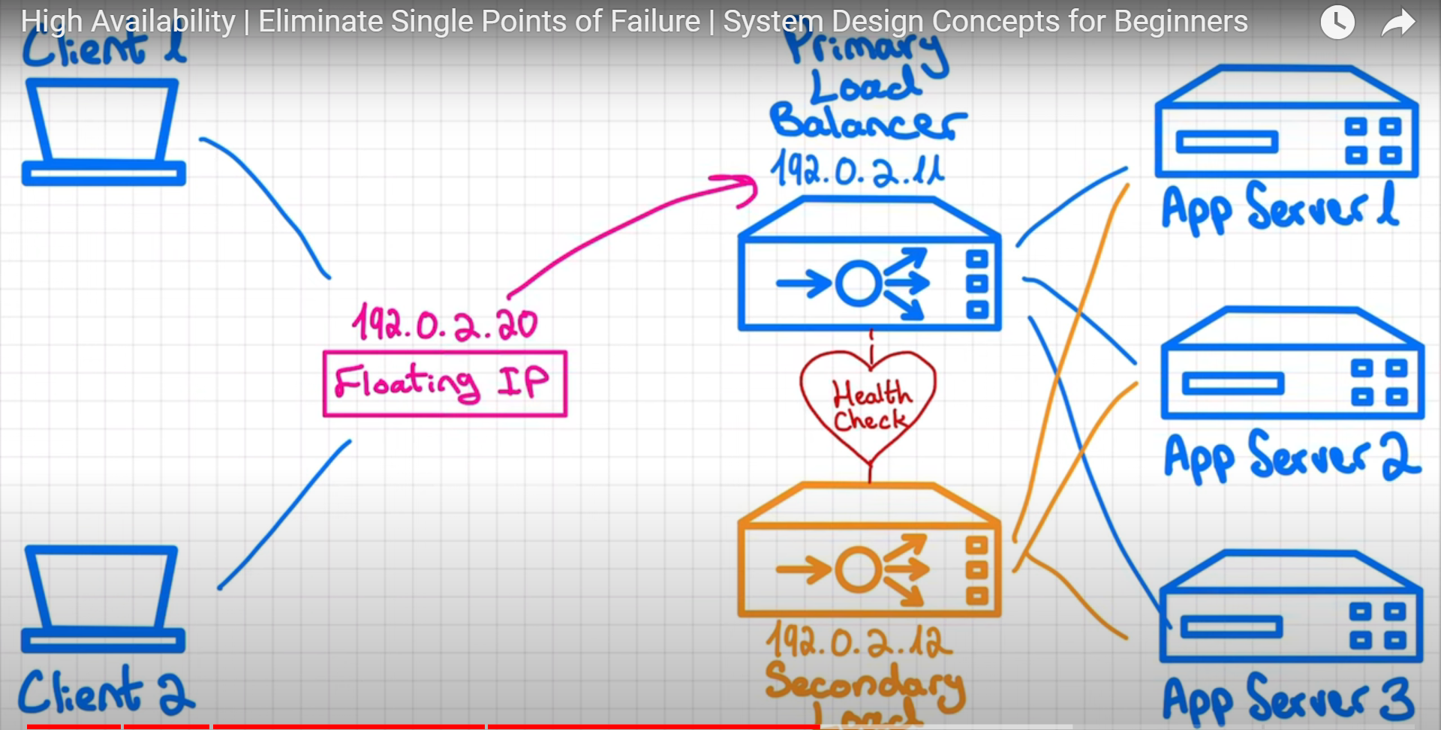

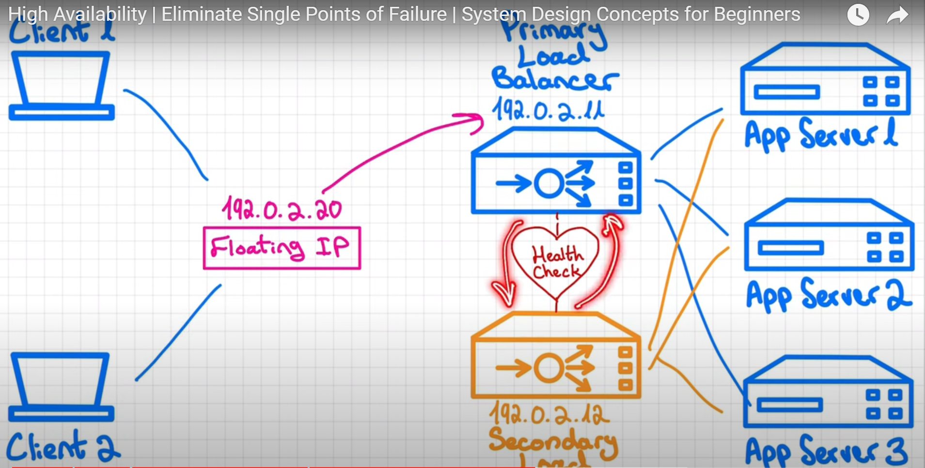

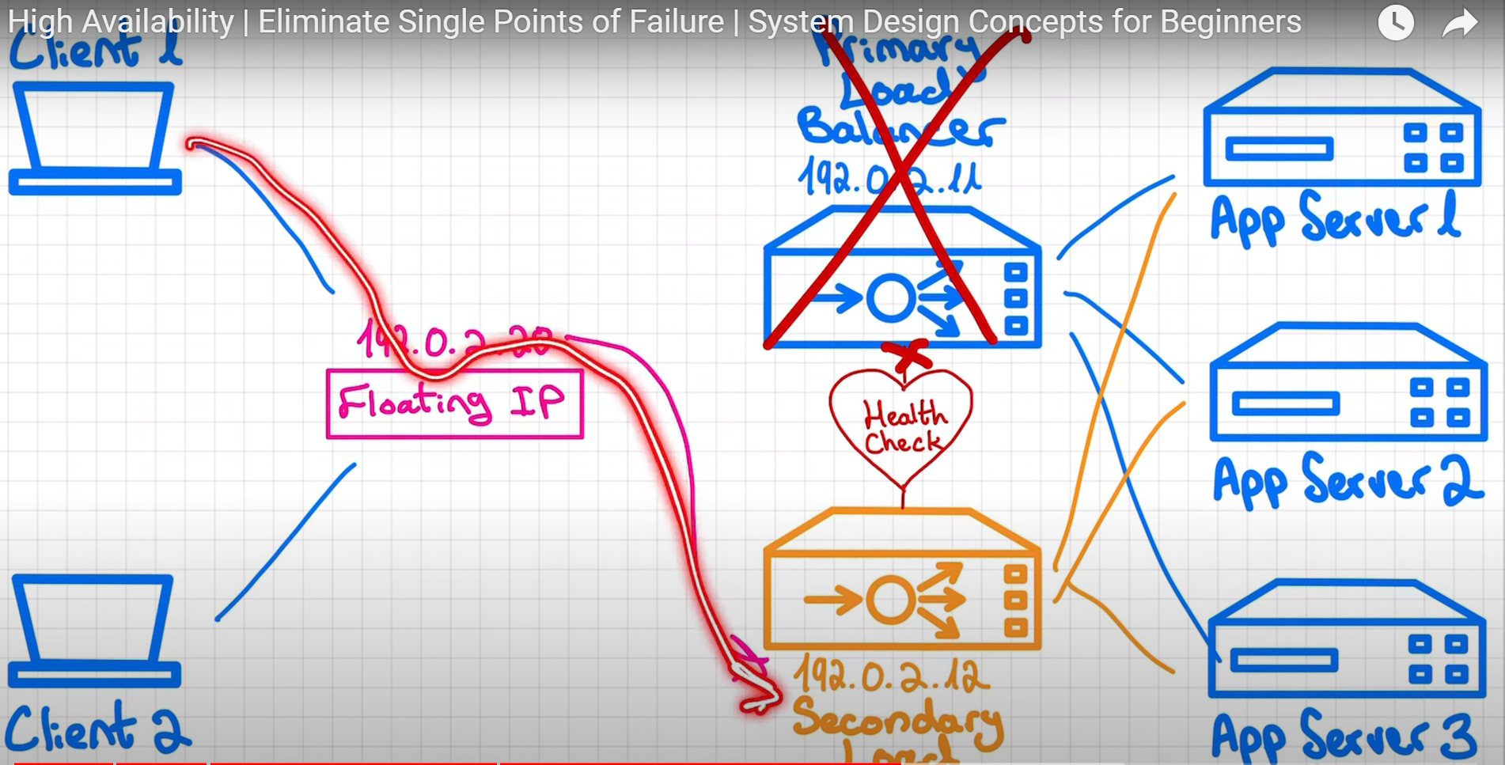

* **2nd solution :**
* Adding DNS server between client and load balancer.
* DNS server will have list of IP addresses for each of domain name.

e.g.

|  |  |
| --- | --- |
| Domain | IP Addresses |
| Google.com-> | {IP1,IP2,IP3,…} |
| Youtube.com-> | {ip1,ip2,ip3,…} |

* Whenever client calls any of domain, DNS server will take 1st IP address and that IP address will be sent to client
* Client can directly make call to load balancer.
* The issue is DNS server will not be aware of which load balancer has failed.
* For that we need to add monitor service to check heartbeats of all load balancers. If heartbeat receive any of load balancer fails, then it will make a call to DNS server to remove the IP address of failed load balancer.
* Update to DNS server by monitor service will not happen instantly. It will only take effect TTL (time to live) for our domain name will expire.

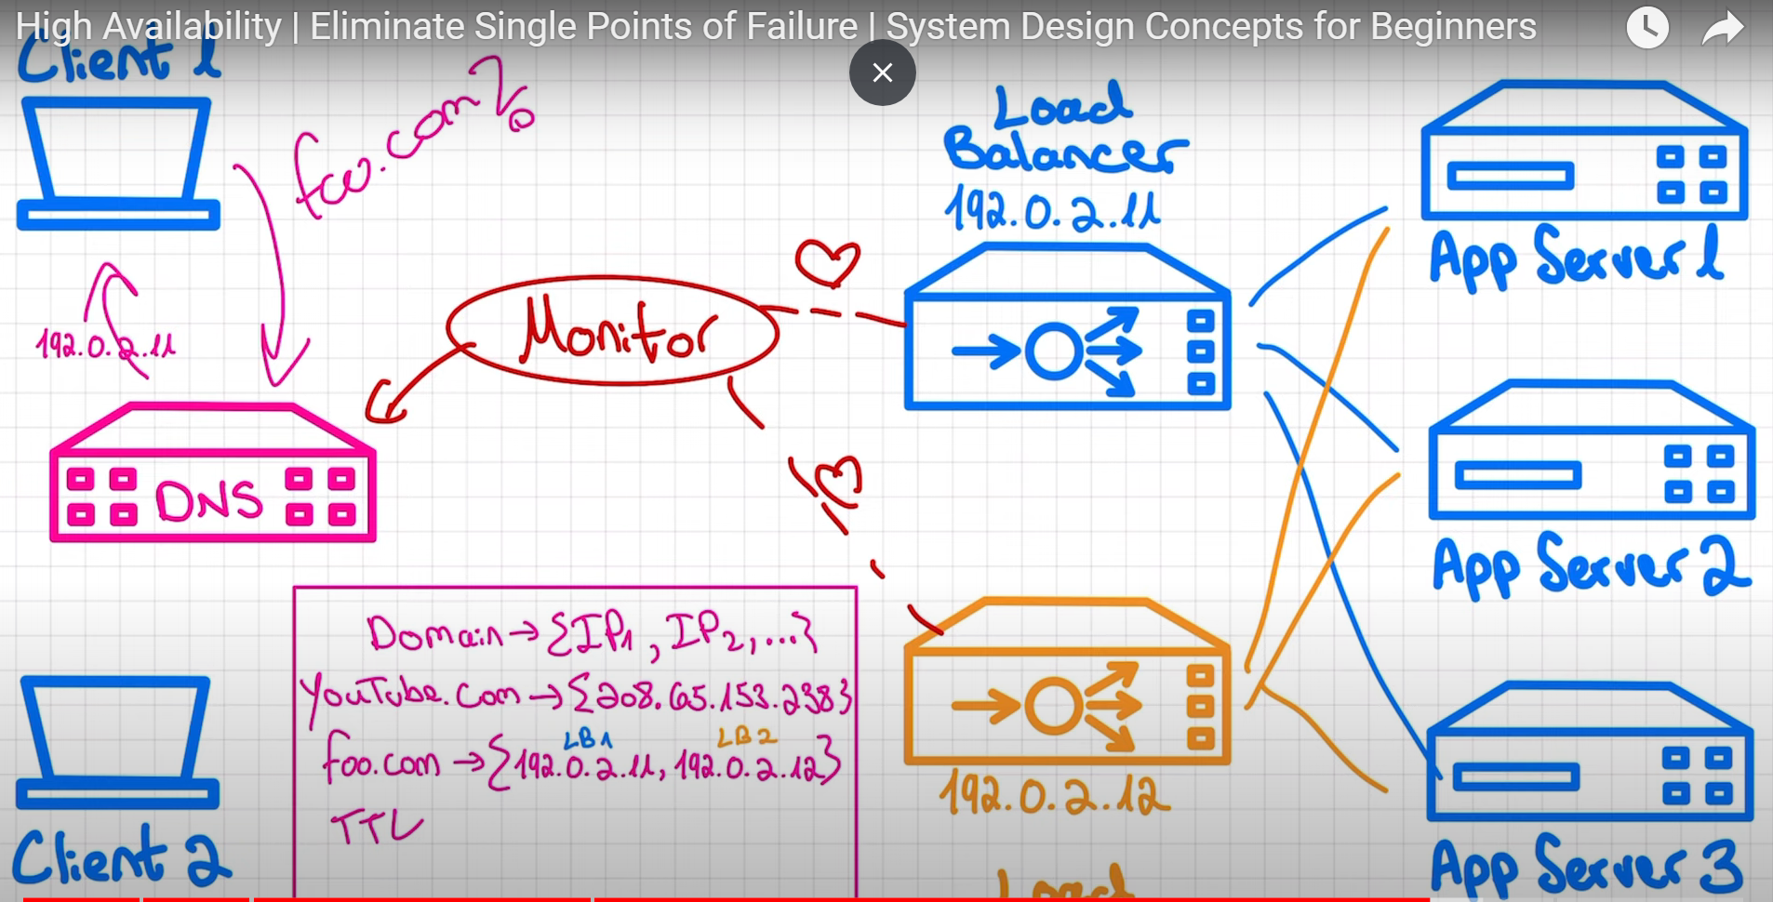

* **Both approaches has their own advantages and disadvantages**
* In floating IP approach, it is self-contained and fail over will be quick as we do not rely on DNS service time to live.
* In DNS server approach, it increases scalability in case load balancers become a bottleneck because of both of load balancers will take requests parallely.
* **Another approach to tackle high availability failure:**
* In case of power outage or natural disaster, it is always better to distribute servers across multiple geographical areas. (e.g. have servers distributed in multiple continents like US, EU,Asia)
* If one region goes down(Asia), then other region can run smoothly.(US)
* Because of this latency gets improved as we will be serving requests at less distance.
* But distributing servers in multiple regions comes with high investment(cost). Because, implement and maintenance is costly.
* It also comes with system complexity. It gets difficult to understand what and where is failure.
* It also poses data consistency challenges.

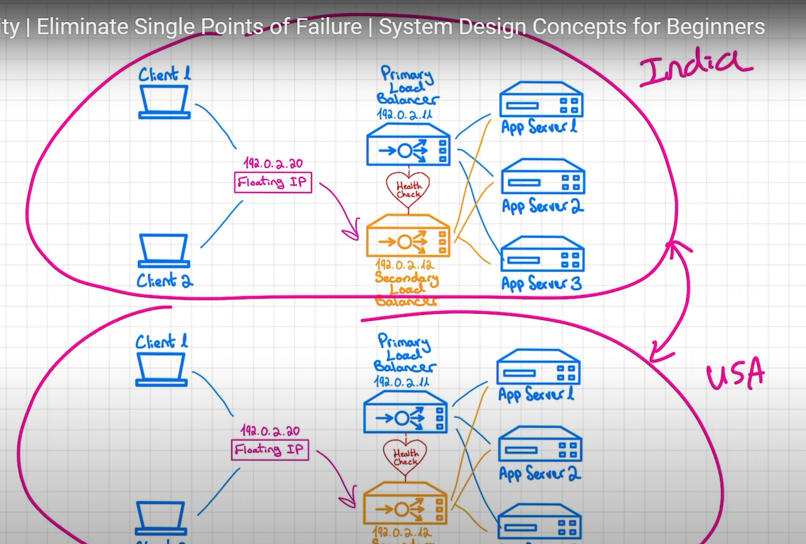

* **some best practices**
* Define your availability goals
* [Choose the right architecture](https://www.linkedin.com/advice/0/what-best-practices-designing-high-availability#choose-the-right-architecture)
* [Implement best coding practices](https://www.linkedin.com/advice/0/what-best-practices-designing-high-availability#implement-best-coding-practices)
* [Test your system thoroughly](https://www.linkedin.com/advice/0/what-best-practices-designing-high-availability#test-your-system-thoroughly)
* [Monitor and optimize your system continuously](https://www.linkedin.com/advice/0/what-best-practices-designing-high-availability#monitor-and-optimize-your-system-continuously)

1. **Define your availability goals**

Before you start designing your system, you need to define your availability goals and metrics. Availability is usually measured by the percentage of time that your system is operational and functional. For example, a 99.9% availability means that your system is down for less than nine hours per year. However, availability also depends on other factors, such as latency, throughput, scalability, and fault tolerance. You need to specify your target values and thresholds for each of these factors and how you will monitor and evaluate them.

1. **Choose the right architecture**

The architecture of your system determines how it is structured, organized, and distributed. It affects how your system handles load balancing, redundancy, replication, backup, recovery, and failover. There are different types of architectures for high-availability systems, such as monolithic, microservices, serverless, or hybrid. Each type has its advantages and disadvantages, depending on your use case, resources, and preferences. You need to choose the right architecture that suits your needs and supports your availability goals.

1. **Implement best coding practices**

The quality of your code also affects the availability of your system. You need to implement best coding practices that ensure your code is readable, maintainable, testable, and secure. You need to follow coding standards, conventions, and guidelines that make your code consistent and easy to understand. You need to use appropriate tools and frameworks that simplify your development process and automate your testing and deployment. You need to apply design patterns and principles that make your code modular, reusable, and extensible. You need to avoid common coding errors and vulnerabilities that can cause bugs, crashes, or breaches.

1. **Test your system thoroughly**

Testing your system is crucial to verify its functionality, performance, and reliability. You need to test your system thoroughly at different levels, such as unit, integration, system, and acceptance. You need to use different testing methods, such as functional, non-functional, load, stress, and security testing. You need to simulate different scenarios, such as normal, peak, and failure conditions. You need to identify and fix any issues or defects that can affect your system's availability.

1. **Monitor and optimize your system continuously**

Monitoring and optimizing your system is an ongoing process that helps you maintain and improve your system's availability. You need to monitor your system continuously using various tools and metrics that collect and analyze data about your system's status, performance, and behavior. You need to optimize your system regularly using various techniques and strategies that enhance your system's efficiency, scalability, and resilience. You need to update and upgrade your system periodically using best practices and standards that keep your system current and compatible.